grep command in Unix/Linux

It is used to search for specific words, phrases, or patterns inside text files, and shows the matching lines on your screen.

Syntax of grep Command in Unix/Linux
The basic syntax of the `grep` command is as follows:

grep [options] pattern [files]

[options]: These are command-line flags that modify the behavior of
grep.
[pattern]: This is the regular expression you want to search for.
[file]: This is the name of the file(s) you want to search within. You can specify multiple files for simultaneous searching.

Example of grep Command in Linux
grep Command is useful when you need to quickly find certain keywords or phrases in logs or documents.

Example 1: Search for a word in a file

If you have a file called notes.txt and you want to find all lines containing the word Python, you can use:

grep "python" notes.txt

Here's the output:

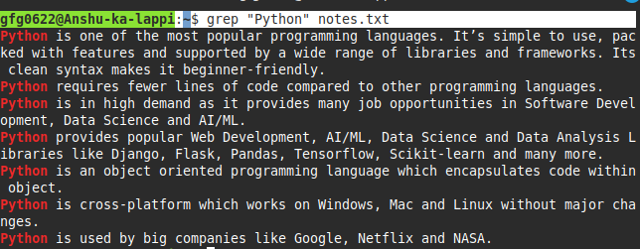

Example 2: Search recursively in all files of a directory

If you want to search for the word error in all files under the /var/log
directory, you can run:

grep -r "error" /var/log

Note: If you are not logged in as the root user, you may need to use sudo to access protected log files, like this:

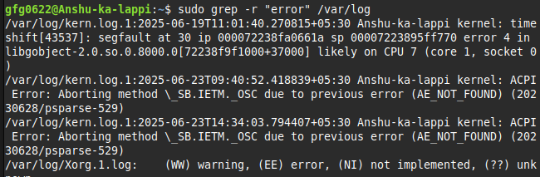
Here, -r tells grep to search recursively, meaning it will look inside all subfolders too.

Options in grep Command in Linux
Its name comes from an old editor command: g/re/p, which stands for “globally search for a regular expression and print. Here are some use cases of grep command:

Case insensitive search
The -i option enables to search for a string case insensitively in the given file. It matches the words like "UNIX", "Unix", "unix".

grep -i "UNix" geekfile.txt

Output:

Case insensitive search

Displaying the Count Matches Using grep
We can find the number of lines that matches the given string/pattern

grep -c "unix" geekfile.txt

Output:
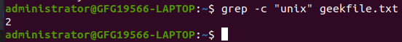
Displaying the count number of the matches

Display the Matching Filenames Using grep
We can just display the files that contains the given string/pattern.

grep -l "unix" *

or

grep -l "unix" f1.txt f2.txt f3.xt f4.txt

Output:
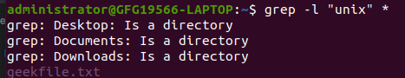
The file name that matches the pattern

Checking Whole Words Using grep
By default, grep matches the given string/pattern even if it is found as a substring in a file. The -w option to grep makes it match only the whole words.

grep -w "unix" geekfile.txt

Output:
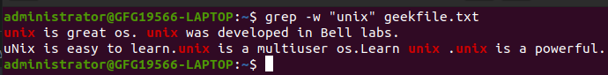
checking whole words in a file

Display Matched Pattern Using grep
By default, grep displays the entire line which has the matched string. We can make the grep to display only the matched string by using the - o option.

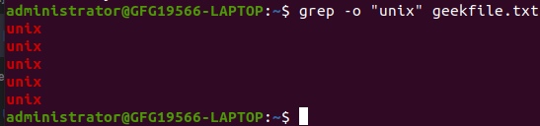
Displaying only the matched pattern

Show Line Numbers with grep -n
To show the line number of file with the line matched.

grep -n "unix" geekfile.txt

Output:
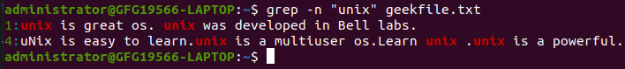
Show line number while displaying the output

Inverting the Pattern Match Using grep
You can display the lines that are not matched with the specified search string pattern using the -v option.

grep -v "unix" geekfile.txt

Output:

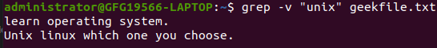
Inverting the pattern match

Match Lines Starting with a String using grep
The ^ regular expression pattern specifies the start of a line. This can be used in grep to match the lines which start with the given string or pattern.

grep "^unix" geekfile.txt

Output:
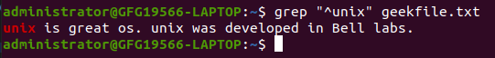
Matching the lines that start with a string

Match Lines Ending with a String using grep
The $ regular expression pattern specifies the end of a line. This can be used in grep to match the lines which end with the given string or pattern.

grep "os$" geekfile.txt

Specifies expression with -e option
Can use multiple times :

grep –e "Agarwal" –e "Aggarwal" –e "Agrawal" geekfile.txt

Use -f to Read Patterns from a File
It is used to search for multiple patterns, listed in a separate file, within another target file.
cat pattern.txt
Agarwal Aggarwal Agrawal
grep –f pattern.txt geekfile.txt

Print Specific Lines from a File with grep
-A prints the searched line and n lines after the result, -B prints the searched line and n lines before the result, and -C prints the searched line and n lines after and before the result.
Syntax:

grep -A[NumberOfLines(n)] [search] [file] grep -B[NumberOfLines(n)] [search] [file] grep -C[NumberOfLines(n)] [search] [file]

Example:

grep -A1 learn geekfile.txt

Output:
